Handboek natuurkundedidactiek | hoofdstuk 2: Les- en leerstofopbouw

2.7 Didactische benaderingen
2.7.9 Practica
Cursusactiviteit | Docentenhandleiding

Practicumveiligheid

Hieronder de (onvertaalde) lijsten met gevaarlijke situaties in beide figuren. Een deel van die gevaarlijke situaties lijkt overigens betrekking te hebben op een scheikundepracticum. En op zijn minst één situatie is deels specifiek voor het land van oorsprong van de figuren.

Figure 1
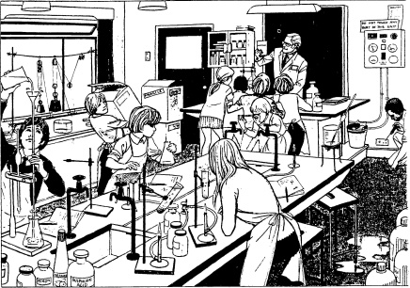
Some of the main hazards:
1 Water on a polished floor.
2 High apparatus standing near the edge of the bench – a beaker on a tripod stand with a long pipette sticking out of the beaker.
3 A child inadvertently putting his hand on a hot metal tripod.
4 A heated test-tube pointed in such a direction that boiling liquid could be ejected on to pupils.
5 A test-tube being heated with an inappropriately large amount of liquid in it.
6 Bottles of inflammable or corrosive materials (e.g. ether or corrosive hydrochloric acid) stored on the floor where they can be bumped into.
7 A retort stand assembled in such a way that when used it will tip over.
8 Rubber tubing trailing among bottles and other apparatus which might thereby be knocked over or swept off the bench. Cluttered benches can be a source of a variety of accidents. Bottles not in use should be removed from the working surface.
9 A metal screwdriver being used to explore a mains socket.
10 Heavy metal weights or other heavy objects being supported on thin string or wire (in the experiment with pulleys).
11 Long hair dangling near Bunsen flames: loose clothing.
12 Chemicals kept in bottles which formerly contained food and which still have labels on them.
13 Liquids being poured above eye-level – in this case into a burette.
14 Exit doors blocked.
15 Pupils too near to a demonstration while watching it.
16 Pupil flicking paper.
17 A pupil carrying loads that obscure his view of where he is walking.
18 Safety notices on the power unit too high to be read easily by pupils.

Figure 2
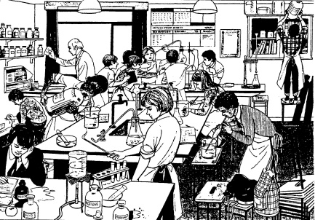
Some of the main hazards:
1 Over-crowding likely to cause pupils to knock apparatus off the bench.
2 Spilled acid on a bench in a position such that clothing might mop it up.
3 Pupil pouring a solution from a very large (Winchester) bottle.
4 Gas cylinders stored in positions where they could fall or be knocked over: they should be chained in position.
5 A pupil standing on a stool to get at heavy apparatus, reaching for it from high up.
6 A jar over the edge of a cupboard could fall off.
7 A pupil trying to light, with a taper, gas coming from a gas-generation apparatus which includes a thistle funnel. (If hydrogen is being prepared this way the apparatus will contain an explosive gas-air mixture.)
8 A test-tube stand on the edge of a bench.
9 Food in among poisonous chemicals.
10 An inflammable solvent (acetone) being heated with a naked flame.
11 Mercury spilled on a bench.
12 Liquid being pipetted by mouth from a vessel in which the pipette tip is only just below the surface.
13 A chart on the wall curling off for lack of drawing pins, capable of being ignited by the nearby burner.
14 Apparatus in such a position that it would be knocked over by opening cupboard doors.
15 Unsupported apparatus.
16 Combined hazards, e.g. stool falls over, hence knocking over other stools in a domino effect.
17 A boy with wet hands putting a plug in a mains socket – notice also that the socket is upside down.
18 Stools and bags blocking walking space.
19 Long hair, not tied, could be a fire hazard for the girls.
20 Loose clothing.

